Name _________Dheeraj______

Practice IA
Topic: To investigate how concentration of HCl that affects the rate of reaction between magnesium and HCl. To measure the rater of reaction, collect the volume of H2 gas.

Chemical Equation: 2HCl + Mg → MgCl2 + H2

Background Information: Rate of reaction is speed at which reactants are used up or products being formed. Rate is affected by concentration of HCl. Increase in concentration of HCl will increase in number of HCl molecules per unit volume. Thus, increases the frequency of effective collisions, resulting in increase in rate of reaction.

Hypothesis: Increase in concentration of HCl will increase the rate of reaction between the HCl and magnesium.

Independent Variable: concentration of HCl
Dependent Variable : Volume of H2 gas collected in a specific period of time

Controlled Variables
List of Controlled variables | How are you going to control the variables
Temperature of solution | Temperature= 25, use thermometer to ensure temperature is constant
Length of magnesium strip | Measure the length of each magnesium strip at 2cm.
Particle size

Chemicals needed
Chemicals needed | Concentration | Quantity
HCl | 2.00 mol/dm3 | 1
Mg | - | Few long strips

Apparatus needed:
List of Apparatus needed | Quantity
50ml measuring cylinder | 2
10ml measuring cylinder | 1
250ml volumetric flask | 1
Delivery tube | 1
Magnesium strips
250ml conical flask | 1
Gas syringe | 1
dropper | 2
Digital stopwatch | 1
googles | 1
beaker | 1

Procedure
- Put the conical flask on the table
- Use a clean 10 cm3 and 50 cm3 measuring cylinders, collect and transfer 10 cm3 of 2M HCl and put it into a conical flask.
- Measure 2cm from the long magnesium strip and cut it.
- Add it into the conical flask and close it immediately and tightly. Start the stopwatch immediately. Swirl the flask twice.
- Record the time taken to collect 20 cm3 of H2 gas. Wash the flask thoroughly and immediately. Ensure it is dry as much as possible
- Repeat it two more times and record the time taken. Calculate the average time taken.
- Repeat the experiment from steps 1-6 for different volume of water such as 10, 20, 30, 40 and 50cm3 and keep the volume of HCl of 10cm3 constant.
- Record all the results and calculate the other concentrations of HCl.

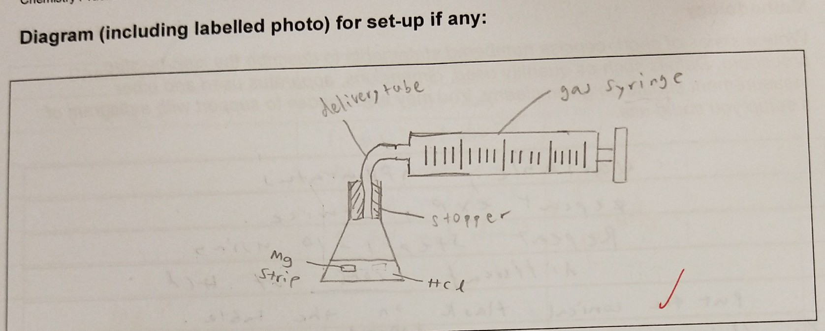
Safety, environmental and ethical issues

Safety: lab coat and gloves and googles should be worn at all time to protect your eyes, skin form hydrochloric acid. HCl causes irritation and is corrosive. Handle with care. Magnesium is flammable and should be careful when handling it.

Analysis
Data collection

Expt | Volume of HCL 2.00 moldm⁻³  ± 1cm³ | Volume of water ± _1__ cm³ | Time taken for collection of H2 gas  ± 0.5 s
 | Volume of HCL 2.00 moldm⁻³  ± 1cm³ | Volume of water ± _1__ cm³ | Trial 1 | Trial 2 | Trial 3 | Average
1 | 10 | 0 | 13.64 | 12.54 | 10.09 | 12.09
2 | 10 | 10 | 44.03 | 43.80 | 41.76 | 43.20
3 | 10 | 20 | 80.00 | 90.00 | 98.00 | 89.33
4 | 10 | 30 | 230.00 | 225.00 | 257.00 | 237.33
5 | 10 | 40 | 297.00 | 281.00 | 307.00 | 295.00

Qualitative observation
Efferversence observed. H2 gas evolved
Control variables : volume of HCl used = ___10____+/- ____1___

- Data processing

Expt | Concentration of Na₂S₂O₃ (mol dm⁻³)  2dp | % uncertainty of conc of HCL | Rate  1/time (s⁻¹)  2sf | % uncertainty of rate  1dp | Total % uncertainty  0dp
1 | 2.00 | 10 % | 0.083 | 4.1% | 14%
2 | 1.00 | 20% | 0.023 | 1.6% | 22%
3 | 0.67 | 17% | 0.011 | 0.6% | 17%
4 | 0.50 | 15% | 0.0042 | 0.2% | 15%
5 | 0.40 | 14% | 0.0034 | 0.2% | 14%

(sample calculation) – from experiment 1

When volume of water used = 10cm3

C1×V1 = C2×V2
2.00×10 = C2×(10+10)
C2 = $\frac{C1×V1}{V2} ±\left(\frac{1}{10}+\frac{2}{20}\right)×100\%$
= $\frac{2.00×10}{20}±20\%$
= 1.00 mol/${dm}^{3}$ ± 20 %
$\frac{1}{t}=\frac{1}{12.09}= 0.0827$ ≈ 0.083 (2s.f.)
Δ$\frac{1}{t} \%=$ $\frac{0.5}{12.09}$× 100%
= 4.1356 ≈ 4.1 %

Total % uncertainty = 14.1% ≈ 14% (0 d.p.)

Average % total uncertainty = $\frac{21.6+14.1+17.6+15.2+14.2}{5}$
=16.46629 %
= 16.5%

Graph

Evaluation
Conclusion: As the concentration increases, the rate of reaction increases which can be concluded from the graph. My hypothesis is valid, given the above analysis.

1/t increases at an increasing rate. There are no anomalous points. The shape of the graph is exponential and curved. When the concentration increases from 0.00 to 2.00 mol/dm-3, rate increases from 0.000 to 0.083.

The average total uncertainty is greater than 5% so there are more random errors than systematic errors.

Sources of errors

Random errors
- Leakage of gas at the mouth of the flask due to holes in the rubber bung or the apparatus is not fully closed tightly. Less volume of gas is collected than actual as some gas escaped. Thus, use plasticine to seal up all possible areas or the rubber bung at the mouth of the flask where leakage might occur for improvement.
- Magnesium strips are inconsistent in sizes. Small size leads to faster rate of reaction and hence time taken may be shorter and vice versa. Therefore, use powdered solid for improvement.
- Human response time is an error which effects volume of gas recorded, may be higher or lower than the actual volume at that specific time. Hence, to improve, repeat the experiment and take average volume of gas collected per unit time.
- High experiment errors such as calibration error. (eg. uncertainty due to measurement using measuring cylinder is high). The reading may be higher or lower than the ideal. So as to improve, use a micropipette to measure small volumes or improve the precision of instruments.

Systematic errors

- Some gas may dissolve directly into the water instead of being collected over water. Less volume of gas is collected than usual as some dissolved into the water to form weak acid. To improve use a data logger to measure the volume or pressure of gas produced or collect the gas using calibrated gas syringe.
- Inability to keep temperature constant. Time taken to complete the reaction may be longer than ideal as heat loss is to the surrounding and the mixture is cooler. To improve us proper insulation for conical flask to maintain and ensure that temperature during reaction is constant.

